# Báo cáo Tuần 1

Table of Contents

Báo cáo Tuần 1 1

Create a repository 2

Create HelloWorld.java 2

Perform Git Action 3

Git add 3

Commit 4

Push 4

Pull 5

Create branch 5

implement calculator using swing and mvc model 6

# Create a repository

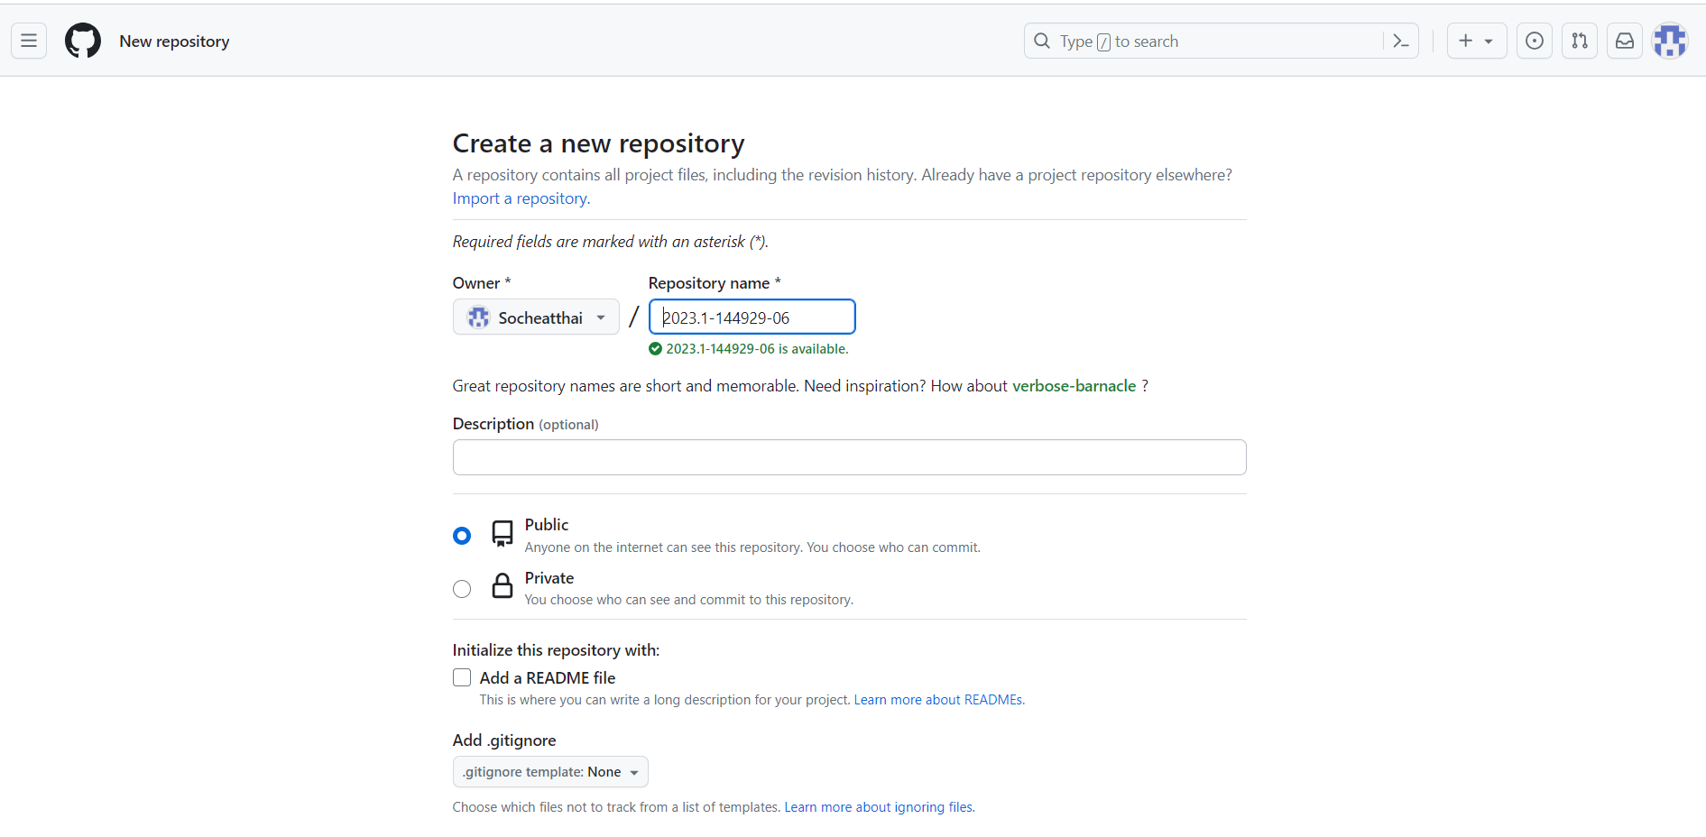

# Create HelloWorld.java

# Perform Git Action

## Git add

## Commit

## Push

## Pull

## Create branch

# implement calculator using swing and mvc model

